**RENTAL PROPERTY MANAGEMENT (LANDLORD ACCOUNTING)**

QuickBooks can simulate the most sought-after features of rental software:

* Bank account balance per property using a shared/joint checking account
* Receivables and payables per property
* Report of income and expense per property
* Security escrow analysis per tenant
* Recurring rent charges
* Lease renewal date tracking and letters
* Tenant information
* Vacancies

This guide summarizes the work-a-rounds that can be used to adapt QuickBooks for the property management industry. The guide Is very brief, and thus intended for readers who are knowledgeable in bookkeeping and familiar with QuickBooks. If you would like more detailed information,

**Managing property for others:**

If you manage properties for others (eg you are a property management firm), it is important to understand you are running two companies - a management company (your entity) and a rental properties company. Thus, you will have two separate sets of books with different needs. This section focuses on the unique accounting needs of rental properties. A rental management firm’s own books will simply show rental management fees earned and related operating costs, using a very straightforward setup of QuickBooks.

**Consolidated vs. separate company files for owners**

If you own more than a couple rental properties, you will probably be happier with a company data file for rental management separate from the data file for program activity and administration. This will facilitate:

1. focused reports of the rental program alone
2. a revenue and expense report with columns for each property (class)
3. a simple Chart of Accounts with only property-related categories
4. the ability to show funds transferred to the general fund for rental management fees

**Bank account balance per property**

using a shared/joint checking account, you can track the cash balance per property using 'subaccounts' of the bank account on the Chart of Accounts.

When a check is written for an expense of a single property, select the correct subbaccount at the top of the screen.

Receivables and payables per property

Xxxxxxxxxxxxxxx

Recurring rent charges

Xxxxxxxxxxxxxxxxxxxxxxxxxxxxxxxxxxx

Lease renewal date tracking and letters

Xxxxxxxxxxxxxxxxxxxxxxxxxxxxxxxxx

Tenant information

Xxxxxxxxxxxxxxxxxxxxxxxxxxxxxxxxxxxxxx

Vacancies

Xxxxxxxxxxxxxxxxxxxxxxxxxxxxxxxxxxxxxxxxxxxxx

**Reporting Per Building**

If you are keeping a separate ledger for rentals: set up a Class for each property. Several properties considered as a single “project” can be grouped, with detail provided by having a sub-class for each, or by using Customer:Job reporting.

The following is a sample "Profit & Loss per Class" report:

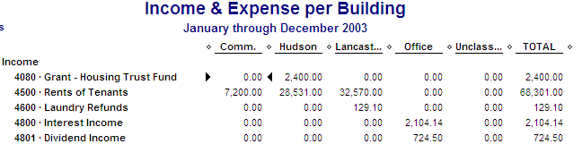

Alternately - if you are keeping rentals within one general ledger, and have few buildings - you may choose to have a single class for rentals within the main company data file. This will keep organization-wide reports readable, but will lack simple tracking of income and expenses on a per-building basis.

Do not create a class for each individual rental unit! Most expenses run per property, not per unit. Thus, it is only accurate to look at a property as a whole. Remember that rent income and single unit information is always available using Customer:Job reports.

**Paying yourself**

If you are managing properties that you own, you cannot (according to accounting standards) “pay yourself” a management fee. Instead, your actual proceeds will equal the net profit/loss of the rentals. If you create categories for management fee expense and the corresponding management fee income, realize that these should be netted together (to total $-0-) on a consolidated financial statement.

**Using the Customer: Job list for tenants and units**

Setting up each separate unit number as a "Customer" with the tenant name being the "Job" - as illustrated below - will allow you to better track information on tenants as they move in and out of units.

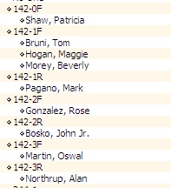

**Tracking tenant rents receivable**

Since it is not necessary to send tenants an Invoice, use Statement Charges to post the rents on the first of each month. It helps to memorize the rental Statement Charges and let the system remind you each month. Set up the memorized transaction to automatically enter dated on the 1st of each month, but to be entered ten days in advance (to accommodate tenants who pay early).

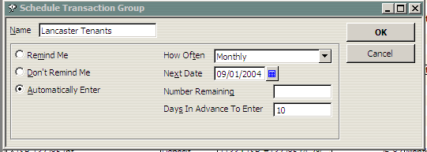

When payments are received, select Receive Payments. The receipt should "Group with other undeposited funds", which will then appear in the list when you Make Deposits.

Using Statement Charges will require setting up a rent charge Item(s). The decision to set up Items is usually driven by the fact that each is linked to one COA account. You should only need one, unless you track rents in different income categories (such as residential vs. commercial). You don’t need to set up an item (and COA category) for each tenant — the Customer:Job reports will track each tenant.

**Rent arrears** (unpaid rents) can then be seen on the Customer list and Open Invoices report. There is a Register for each tenant’s history. To see a report of open balances for tenants only - in case you also have other types of receivable - select an A/R report, then filter it to show only Customer Type of “tenant”. (You did remember to label each tenant with a Customent Type, didn’t you?). Remember to give your custom report a name (use the Header button), and Memorize the report.

**Vacancies** can be handled either by not recording them. Alternatively, to show the vacancy as an expense, charge rent and then credit vacancy expense. To record the vacancy expense in QuickBooks:

(1) use a mock tenant named “vacancy” to record a rent charge

(2) create an Item called "vacancy" that posts to the vacancy expense account

(3) record the vacancy expense as a Credit Memo (or as a negative Statement Charge) using an Item

(4) apply the credit against the charge using Receive Payments.

**Security Deposits**

**Xxxxxxxxxxxxxxxxxxxxx**

* reconcile account for clients who have been paid out
* double click liability account
* filter for cleared status "no".

**---------------------------------------------------------------**

Checking account balance per property - use subcategories of the bank account*

Receivables and payables per property - use subcategories of the A/R and A/P account*

Report of income and expense per property - use Classes for each property

Security escrow analysis - create a Transaction report of the "security held" liability account

Recurring rents - use Memorized Transactions to record a group of rents monthly

Lease renewals - use the Reminders feature

Tenant information - add custom fields to the Customers list

Track vacancies - using a “mock” customer, charge rent but subtract vacancy cost

**HINTS & TIPS**

**Always assign a Class to revenue and expense items**

To get an accurate picture of your funds, you must classify every transaction in QuickBooks. If a transaction doesn’t apply to the general fund, or to any other fund, classify it as “other.” When you create reports, any transaction you forgot to classify will be listed as “unclassified,” and you can easily go back and correct it by double clicking it on the report.

**Use Classes for only one purpose**

Don’t mix tracking with any other purpose, such as tracking by region.

**Limit the number of classes**

Keep a number that can fit across one pages (landscape orientation). Remember that Customer:Job reports can be used for tracking small or non-recurring projects.

**Using items on non-invoiced cash receipts**

To use items on cash receipt of a donation or other cash receipt, use the two-step process of recording a cash sale then depositing it.

**Using numbers on the Chart of Accounts list**

Account numbers or optional in QuickBooks, and can be easily turned on and off. Thus, you can maintain numbers, but hide them during daily usage and reporting. [To turn numbers on/off, click on Preferences: Transactions.]

You should assign numbers for all categories that will appear on your financial statements, but can optionally leave them off both for group headings and for subaccounts providing detail beyond the financial requirements.

Similarly, you can change the order of the Chart of Accounts at any time; it need not be in numerical order. Since the COA forms the basis of reports, take advantage of the flexibility. Feel free to improve the order and grouping for your internal reporting purposes. For example, you can arrange the operating costs in the order required by the DHCR semi-annual and annual reports. Remember to change back to numeric order when preparing the records for audit.

**Budgeting**

Budgets do not have to be monthly, as per the budget entry screen. Most nonprofits budget annually. Put the annual budget figure in the first month of the year. Year-to-date reports will then include the full annual budget.

For modifications, enter the amount added or subtracted in the month effective. This will give a record or the original and the changes, and preserve the budget reports previously created.

**To Be Classified**

When you are entering data, and you’re unsure of a transaction, post it to a To Be Classified category. Later, do a QuickReport of To Be Classified, and zoom in to change the transaction.